**Supplementary material**

**Table S1.** Description of the samples and results from proteomic (S: sheep, G: goat, S/G: caprine indet., C: cattle, Cam: camel, ?: undetermined) and stable isotopes analysis. Samples with C/N > 3.8 were removed from data analysis. Pictures of each sample were previously published and can be found in the Table S2 of Supplementary material from Azémard et al. 2019 30.

|  |  |  |  |  |  |  |  |  |  |
| --- | --- | --- | --- | --- | --- | --- | --- | --- | --- |
| **n° site** | **sample ID** | **discovery context** | **tomb ID** | **object number** | **description** | **species** | **Isotope value** | | |
| **NORTHERN CEMETERY (NC + date of excavation)** | | | | | | | | | |
| ***Textile*** |  |  |  |  |  |  | C/N | 15N | 13C |
| NC 2011 | P55 | Surface collection (scattered funeral remains) |  | 538 | shoelace | S/G | 3.6 | 8.01 | -20.22 |
| NC 2008 | P70 | Surface collection (scattered funeral remains) |  | 542 | shoe | C | 3.8 | 12.42 | -20.87 |
| NC 2008 | P77 | Surface collection (scattered funeral remains) |  | 545 | Shoe | C | 3.7 | 12.53 | -20.97 |
| NC 2011 | P91 | Surface collection (scattered funeral remains) |  | ML 19 | shroud | S | 3.6 | 7.79 | -19.6 |
| NC 2011 | P92 | Surface collection (scattered funeral remains) |  | ML-19 |  | S | 3.5 | 7.39 | -19.9 |
| NC 2008 | P93 | Surface collection (scattered funeral remains) |  | ML 01/47 DC | shroud + pillow | S | 3.8 | 10.2 | -19.93 |
| NC 2008 | P94 | Surface collection (scattered funeral remains) |  | ML 01/47 DC | shroud + pillow | G | 3.6 | 9.69 | -13.58 |
| NC 2011 | P96 | Surface collection (scattered funeral remains) |  | ML 63 | wool fragment | S | 3.6 | 7.59 | -19.49 |
| NC 2011 | P98 | Surface collection (scattered funeral remains) |  | ML 63 saG 3.3 | shroud fragment ? | S | 3.6 | 8.12 | -20.9 |
| NC 2008 | P99 | Surface collection (scattered funeral remains) |  | ML 51 | felt hat | S | 4.2 | 7.76 | -19.93 |
| NC 2011 | P103 | Surface collection (scattered funeral remains) |  | MLY-61 | bag 2.1 | S | 3.7 | 9.03 | -19.09 |
| NC 2008 | P112 | Surface collection (scattered funeral remains) |  | 558 | pagne (?) | S | 3.7 | 10.84 | -20.8 |
| NC 2008 | P114 | Surface collection (scattered funeral remains) |  | 560 | brown shoelace | S | 3.6 | 7.57 | -21.09 |
| NC 2008 | P115 | Surface collection (scattered funeral remains) |  | 561 | shoelace | S | 3.5 | 9.05 | -20.88 |
| NC 2008 | P116 | Surface collection (scattered funeral remains) |  |  | weaved cord | S | 3.7 | 8.34 | -21.53 |
| NC 2011 | P118 | Surface collection (scattered funeral remains) |  | ML 33 | child shroud | S | 4.0 | 9.06 | -19.61 |
| NC 2008 | P120 | Surface collection (scattered funeral remains) |  | ML-07 | pagne | S/G | 3.9 | 8.09 | -20.88 |
| NC 2011 | P123 | Surface collection (scattered funeral remains) |  | ML-56 | brown shroud | S | 3.6 | 7.66 | -19.7 |
| NC 2008 | P125 | Surface collection (scattered funeral remains) |  | ML 15 | strip of cloth | S/G | 4.2 | 8.38 | -19.1 |
| NC 2011 | P126 | Surface collection (scattered funeral remains) |  | ML 27 | baby shroud ? | S/G | 3.8 | 7.92 | -19.96 |
| NC 2008 | P127 | Surface collection (scattered funeral remains) |  | ML 16 | strip of cloth | S | 3.7 | 8.07 | -19.96 |
| NC 2011 | P130 | Surface collection (scattered funeral remains) |  | ML 17-1 | belt | ? | 3.8 | 12.06 | -18.65 |
| NC 2011 | P133 | Excavation of a preserved tomb | M12 | M12.1 | red shroud | S | 3.9 | 8.78 | -20.19 |
| NC 2011 | P145 | Surface collection (scattered funeral remains) |  | ML 28 | shroud | S/G | 3.8 | 8.95 | -18.11 |
| NC 2011 | P147 | Surface collection (scattered funeral remains) |  | ML 28 | shroud fringes | S | 3.5 | 9.77 | -19.59 |
| NC 2011 | P151 | Excavation of a preserved tomb (partially mummified) | M2 | M2.3 | shroud | S | 3.7 | 8.09 | -21.6 |
| NC 2008 | P152 | Excavation of a preserved tomb (partially mummified) | M2 | M2.1 | pagne | S/G | 3.9 | 10.58 | -20.77 |
| NC 2011 | P154 | Surface collection (scattered funeral remains) |  | ML-64 | shroud fragment | S | 3.6 | 6.37 | -19.89 |
| NC 2011 | P159 | Surface collection (scattered funeral remains) |  | ML-57 | shroud | S | 3.5 | 8.18 | -20.69 |
| NC 2008 | P160 | Surface collection (scattered funeral remains) |  |  | red belt | S/G | 4.0 | 8.47 | -18.27 |
| NC 2008 | P164 | Surface collection (scattered funeral remains) |  | ML 49 | long rope | S | 3.7 | 10.79 | -15.32 |
| NC 2008 | P165 | Surface collection (scattered funeral remains) |  | ML-01 | pagne | S | 3.6 | 7.37 | -20.99 |
| NC 2008 | P166 | Surface collection (scattered funeral remains) |  | ML 50 | skirt fringe | S/G | 3.7 | 8.06 | -19.3 |
| NC 2011 | P167 | Surface collection (scattered funeral remains) |  | ML-24 |  | S | 3.6 | 7.96 | -20.04 |
| NC 2008 | P172 | Surface collection (scattered funeral remains) |  | ML 05 | thong with fringes (pagne?) | S/G | 3.7 | 10.25 | -19.39 |
| NC 2011 | P174 | Surface collection (scattered funeral remains) |  | ML 60 SAG 1.6 | woolen shroud | S | 3.6 | 6.74 | -20.08 |
| NC 2011 | P176 | Surface collection (scattered funeral remains) |  | ML 52 SAG 3.2 | textille fragment | S | 3.7 | 8.46 | -20.76 |
| NC 2011 | P178 | Surface collection (scattered funeral remains) |  | ML 51 SAG 1.8 | shroud trim | S | 4.1 | 7.68 | -19.41 |
| NC 2011 | P179 | Surface collection (scattered funeral remains) |  | ML-51 | shroud | S/G | 3.7 | 7.43 | -19.58 |
| NC 2011 | P183 | Surface collection (scattered funeral remains) |  | ML-54 | shroud | S | 3.6 | 6.89 | -19.52 |
| NC 2011 | P184 | Surface collection (scattered funeral remains) |  | ML 59 SaG 1.5 | shroud fragments | S | 3.5 | 6.6 | -20.74 |
| NC 2011 | P185 | Surface collection (scattered funeral remains) |  | ML-59 | shroud fragments | S | 3.5 | 7.66 | -20.25 |
| NC 2011 | P187 | Surface collection (scattered funeral remains) |  | ML 55 SaG 1 | shroud | S | 3.8 | 8.34 | -18.99 |
| NC 2011 | P 189 | Surface collection (scattered funeral remains) |  | ML-49 | bag 2,3 | S | 3.6 | 7.05 | -19.29 |
| NC 2011 | P191 | Surface collection (scattered funeral remains) |  | ML-20 | shroud | S | 3.6 | 8.35 | -19.38 |
| NC 2011 | P192 | Surface collection (scattered funeral remains) |  | ML-23 | badly conserved | S | 3.5 | 8.01 | -20.67 |
| NC 2011 | P193 | Surface collection (scattered funeral remains) |  | ML-23 | badly conserved | S | 3.5 | 8.97 | -19.54 |
| NC 2011 | P195 | Excavation of a preserved tomb (partially mummified) | M3 | M3.5 | shroud with brown and pink band | S | 3.6 | 8.81 | -20.23 |
| NC 2011 | P198 | Surface collection (scattered funeral remains) |  | ML-47 | bag 3.1 | S | 3.8 | 8.89 | -21.11 |
| NC 2011 | P199 | Surface collection (scattered funeral remains) |  | ML 48 SaG 2.4 | fringes | S | 3.5 | 7.63 | -21.43 |
| NC 2011 | P201 | Surface collection (scattered funeral remains) |  | ML 30 | fragment | S | 3.6 | 7.87 | -18.29 |
| NC 2011 | P202 | Surface collection (scattered funeral remains) |  | ML 30 | fragment | S | 3.7 | 8.23 | -18.56 |
| NC 2011 | P203 | Surface collection (scattered funeral remains) |  | ML 30 | fragment | S | 3.8 | 9.73 | -18.85 |
| NC 2011 | P204 | Excavation of a preserved tomb | M12 | M 12.5 | brown shroud | S | 3.6 | 7.93 | -19.92 |
| NC 2011 | P205 | Excavation of a preserved tomb | M12 | M 12.5 | brown shroud | S | 3.7 | 8.5 | -19.78 |
| NC 2011 | P206 | Surface collection (scattered funeral remains) |  | ML-31 | big shroud with thin red bands | S | 3.7 | 5.02 | -20.04 |
| ***Hide*** |  | Surface collection (scattered funeral remains) |  |  |  |  |  |  |  |
| NC 2011 | P215 | Surface collection (scattered funeral remains) |  | 563 |  | G | 3.6 | 7.25 | -21.13 |
| NC 2011 | P216 | Surface collection (scattered funeral remains) |  | 563 |  | G | 3.5 | 8.06 | -20.89 |
| NC 2011 | P220 | Surface collection (scattered funeral remains) |  | 565 | Coffin covering | C | 3.6 | 9.29 | -20.13 |
| NC 2011 | P222 | Surface collection (scattered funeral remains) |  | 566 |  | G | 3.5 | 7.23 | -20.18 |
| NC 2011 | P225 | Surface collection (scattered funeral remains) |  | 569 |  | G | 3.5 | 9.08 | -21.44 |
| NC 2011 | P226 | Surface collection (scattered funeral remains) |  | 569 | two hides sewed together | G | 3.5 | 6.63 | -21.14 |
| NC 2011 | P227 | Excavation of a preserved tomb | tomb M11 | 570 |  | S | 3.5 | 8.34 | -17.83 |
| NC 2011 | P230 | Surface collection (scattered funeral remains) |  | 572 | beige, short hair | S | 3.5 | 7.64 | -21.43 |
| NC 2011 | P235 | Surface collection (scattered funeral remains) |  | 575 | brown and creme | S | 3.6 | 10.62 | -13.33 |
| NC 2011 | P236 | Surface collection (scattered funeral remains) |  | 576 | blond hairs | S | 3.6 | 7.07 | -20.56 |
| NC 2011 | P237 | Surface collection (scattered funeral remains) |  | 577 | brown, short, curly | S/G | 3.6 | 6.83 | -20.39 |
| NC 2011 | P238 | Surface collection (scattered funeral remains) |  | 578 |  | S | 3.6 | 6.99 | -19.47 |
| NC 2011 | P239 | Surface collection (scattered funeral remains) |  | 579 | brown and cream | S | 3.6 | 6.43 | -20.61 |
| NC 2011 | P242 | Surface collection (scattered funeral remains) |  | 582 |  | S | 3.5 | 10.29 | -20.8 |
| NC 2011 | P243 | Surface collection (scattered funeral remains) |  | 583 | short, light brown | ? | 3.6 | 12.04 | -15.85 |
| NC 2011 | P245 | Surface collection (scattered funeral remains) |  | 584 | red hair | C | 3.5 | 9.83 | -21.49 |
| NC 2011 | P246 | Surface collection (scattered funeral remains) |  | 585 | brown short hair | C | 3.5 | 8,0 | -21.53 |
| NC 2011 | P247 | Surface collection (scattered funeral remains) |  | 586 | white to red short hairs | C | 3.5 | 9.95 | -21.27 |
| NC 2011 | P249 | Surface collection (scattered funeral remains) |  | 588 | muff | C | 3.5 | 8.79 | -20.27 |
| NC 2011 | P250 | Surface collection (scattered funeral remains) |  | 589 | coffin covering? Short brown hair | C | 3.5 | 9.6 | -21.11 |
| NC 2011 | P251 | Surface collection (scattered funeral remains) |  | 590 |  | G | 3.6 | 5.85 | -21.25 |
| NC 2011 | P252 | Surface collection (scattered funeral remains) |  | 591 | light beige to dark brown | G | 3.6 | 6.65 | -20.13 |
| NC 2011 | P253 | Surface collection (scattered funeral remains) |  | 591 | light beige to dark brown | G | 3.6 | 6.33 | -20.06 |
| NC 2011 | P254 | Surface collection (scattered funeral remains) |  | 592 | brown | G | 3.6 | 8.24 | -20.28 |
| NC 2011 | P255 | Surface collection (scattered funeral remains) |  | 592 | brown | G | 3.6 | 9.07 | -21.19 |
| NC 2011 | P257 | Surface collection (scattered funeral remains) |  | 594 | Brown to light blond | G | 3.5 | 7.48 | -19.73 |
| NC 2011 | P259 | Surface collection (scattered funeral remains) |  | 596 |  | S | 3.6 | 7.31 | -21,0 |
| NC 2011 | P260 | Surface collection (scattered funeral remains) |  | 597 | brown with white spots | G | 3.6 | 7.65 | -20.51 |
| NC 2011 | P261 | Surface collection (scattered funeral remains) |  | 598 | Long and brown | G | 3.5 | 6.54 | -18.92 |
| NC 2011 | P262 | Surface collection (scattered funeral remains) |  | 599 |  | S | 3.7 | 8.89 | -19.27 |
| NC 2011 | P263 | Surface collection (scattered funeral remains) |  | 611 | white to red/brown | S/G | 3.4 | 5.08 | -20.41 |
| NC 2011 | P264 | Surface collection (scattered funeral remains) |  | 612 | white and brown spots | G | 3.6 | 5.67 | -21.01 |
| NC 2011 | P265 | Surface collection (scattered funeral remains) |  | 613 | short, curly, white hairs | S | 3.5 | 6.12 | -21.25 |
| NC 2011 | P266 | Surface collection (scattered funeral remains) |  | 614 | short, curly, white hairs | S | 3.5 | 7.94 | -16.53 |
| NC 2011 | P267 | Surface collection (scattered funeral remains) |  | 615 | short, curly, white hairs | S | 3.6 | 8.87 | -16.55 |
| ***Plant*** |  |  |  |  |  |  |  |  |  |
| NC 2008 | P64 | Surface collection (scattered funeral remains) |  |  | millet |  | n.a. | grain | -12.15 |
| **Djoumboulak Koum (DK + date of excavation)** | | | | | | | | | |
| DK 2001 - F4 zone | P377 | Excavation of a settlement | Dwelling F4 | 143 | hide | G | 3.6 | 9.73 | -18.36 |
| DK 2001 - F4 zone | P378 | Excavation of a settlement | Dwelling F4 | 143 | hair | Cam | 3.4 | 9.04 | -15.43 |
| DK 2001 - F4 zone | P381 | Excavation of a settlement | Dwelling F4 | 147 | hide (shoe?) | C | 3.5 | 10.16 | -15.51 |
| DK 2001 - F4 zone | P384 | Excavation of a settlement | Dwelling F4 | 60 | brown hide | S | 4.5 | 9.15 | -15.77 |
| DK 2001 - F4 zone | P387 | Excavation of a settlement | Dwelling F4 | 152 | hide, long beige hairs | G | 3.5 | 8.51 | -17.79 |
| DK 1996 - cemetery MB | P400 | Excavation of a poorly preserved tomb (scattered) | MB1 | 12-1A | skirt fragment | S/G | 3.6 | 8.84 | -19.77 |
| DK 1996 - cemetery MB | P406 | Excavation of a poorly preserved tomb (scattered) | MB3 | 53-6 | hairs | S | 3.6 | 9.09 | -19.73 |
| DK 1996 - cemetery MB | P410 | Excavation of a poorly preserved tomb (scattered) | MB5 | 1 | strand of fleece | S | 3.5 | 7.8 | -19.47 |
| DK 1996 - cemetery MB | P413 | Excavation of a poorly preserved tomb (scattered) | MB5 | 3-1 | Cream felt | S | 3.9 | 7.78 | -20.15 |
| DK 1996 - cemetery MB | P414 | Excavation of a poorly preserved tomb (scattered) | MB5 | 5 | fur | S | 3.5 | 8.47 | -20.35 |
| DK 1996 - cemetery MB | P415 | Excavation of a poorly preserved tomb (scattered) | MB5 | 11 | hide + textile fragments (purse?) | S | 3.7 | 9.78 | -19.11 |
| DK 1996 - cemetery MB | P416 | Excavation of a poorly preserved tomb (scattered) | MB5 | 11 | hide + textile fragments (purse?) | S/G | 4.2 | 11.95 | -17.46 |
| DK 1996 -cemetery MB | P417 | Excavation of a poorly preserved tomb (scattered) | MB5 | 06-1 | red hessian | S | 3.7 | 10.38 | -19.06 |
| DK 1996 - cemetery MB | P419 | Excavation of a poorly preserved tomb (scattered) | MB5 | 20-5 | fur | S | 3.5 | 7.21 | -20.64 |
| DK 1996 - cemetery MB | P420 | Excavation of a poorly preserved tomb (scattered) | MB5 | 4 | felt boot (?) | S | 3.8 | 7.66 | -20.53 |
| DK 1996 - cemetery MB | P421 | Excavation of a poorly preserved tomb (scattered) | MB1 | 13 | fur | S | 3.5 | 7.95 | -20.6 |
| ***Plant*** |  |  |  |  |  |  |  |  |  |
| DK 2001 - cemetery MD | P210 | Excavation of a well preserved tomb (mummy) | MD13 | MD 13 | barley |  | n.a. | straw | -23.22 |
| DK 2001 - cemetery MD | P211 | Excavation of a well preserved tomb (mummy) | MD13 | MD 13 | reed |  | n.a. | stem | -22.77 |
| DK 2001 - cemetery MD | P212 | Excavation of a well preserved tomb (mummy) | MD13 | MD 15 | barley |  | n.a. | straw | -24.18 |
| DK 2001 - cemetery MD | P213 | Excavation of a well preserved tomb (mummy) | MD13 | MD 15 | Tamarix |  | n.a. | stem | -25.78 |

**Fig. S1 -** Topographical plan of the Keriya North Cemetery before excavation. Coffin boards and burial contents scattered on the surface. In yellow: fragments of textiles corresponding to the clothing and shrouds of the deceased and fragments of sheep and cattle skins covering the wooden burials. © MAFCX – J. Suire

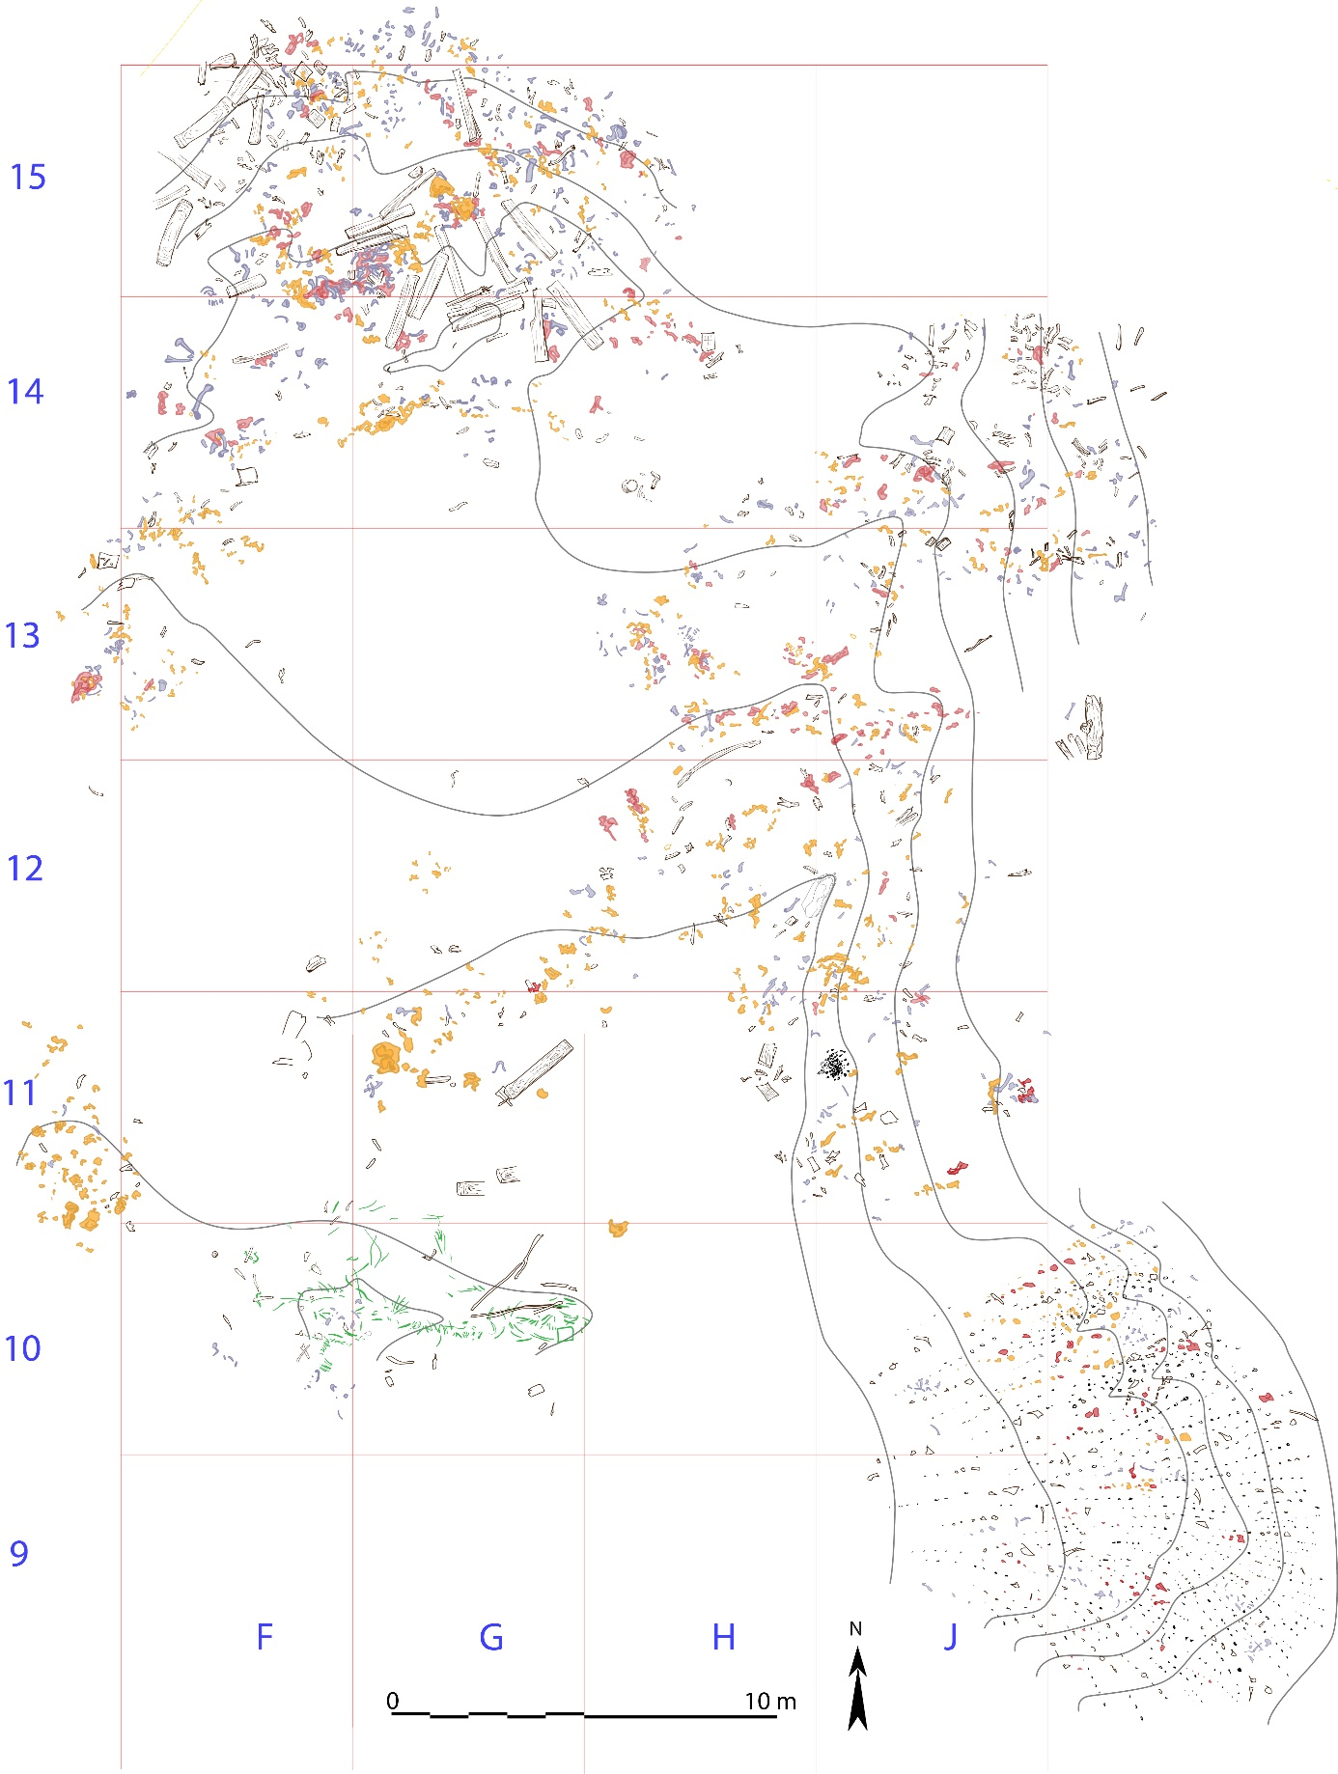

**Fig. S2 -** Topographic situation of the fortified site of Djoumboulak Koum (Yuansha gucheng), and the different cemeteries (MA, MB, MD & ME). © MAFCX – J. Suire

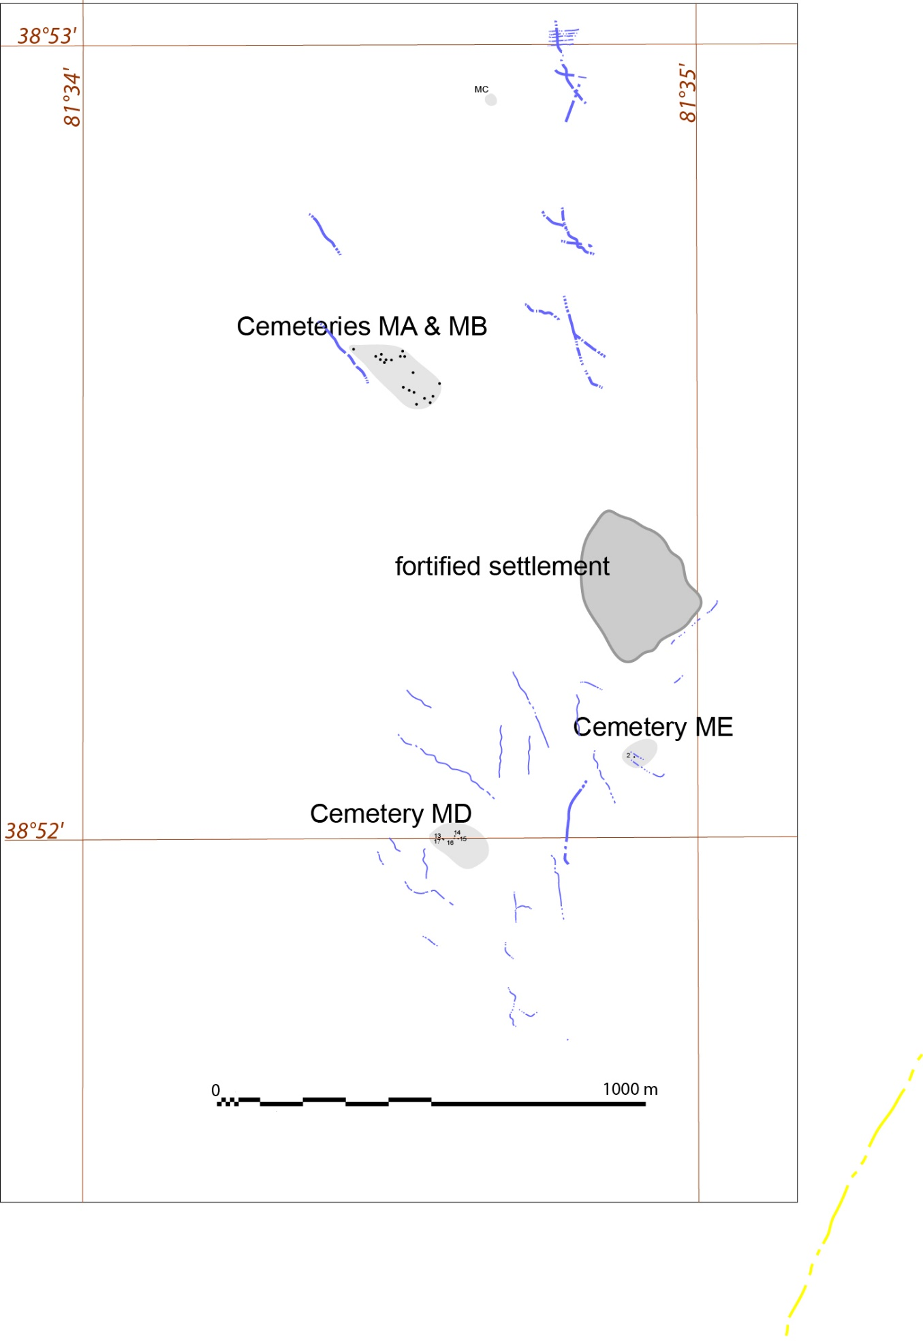

**Fig. S3 -** Topographic map of the fortified site of Djoumboulak Koum (Yuansha gucheng), whose ramparts emerge from the surrounding dunes. In rectangles: excavated intra muros dwellings. © MAFCX – J. Suire

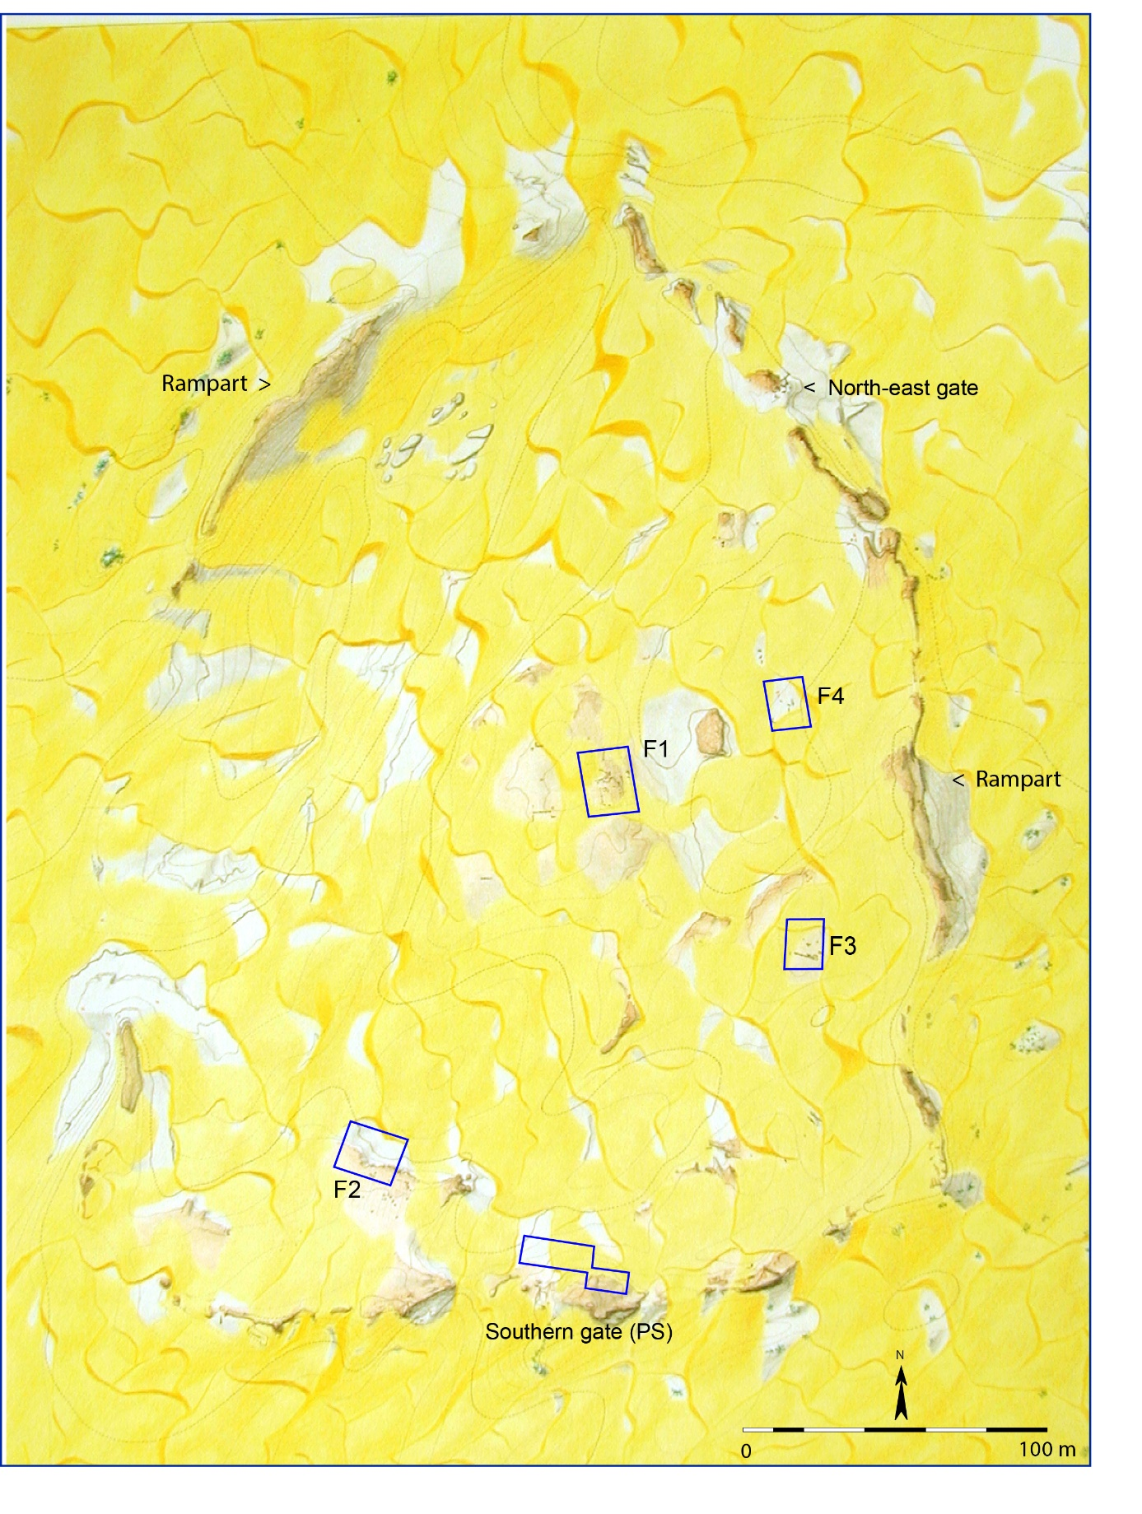

Fig. S4 - North Cemetery. Scattered funeral remains. © MAFCX

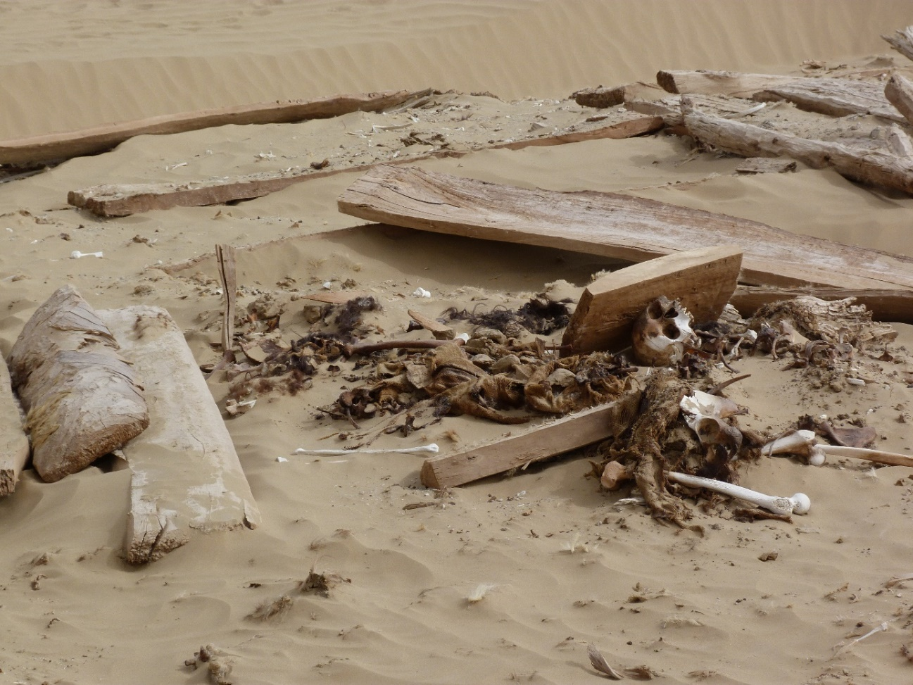

**Fig. S5 -** North Cemetery. Detail of a scattered rope. © MAFCX

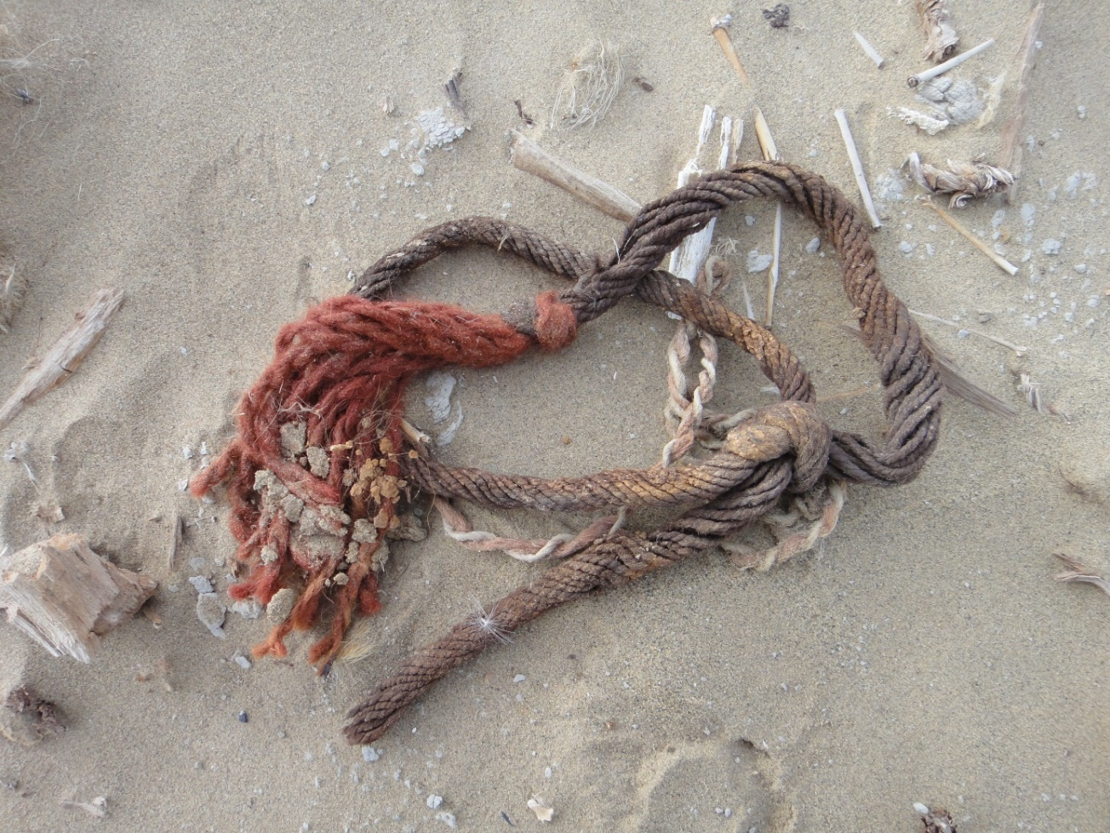

**Fig. S6 -** North Cemetery. Tomb M3. © MAFCX

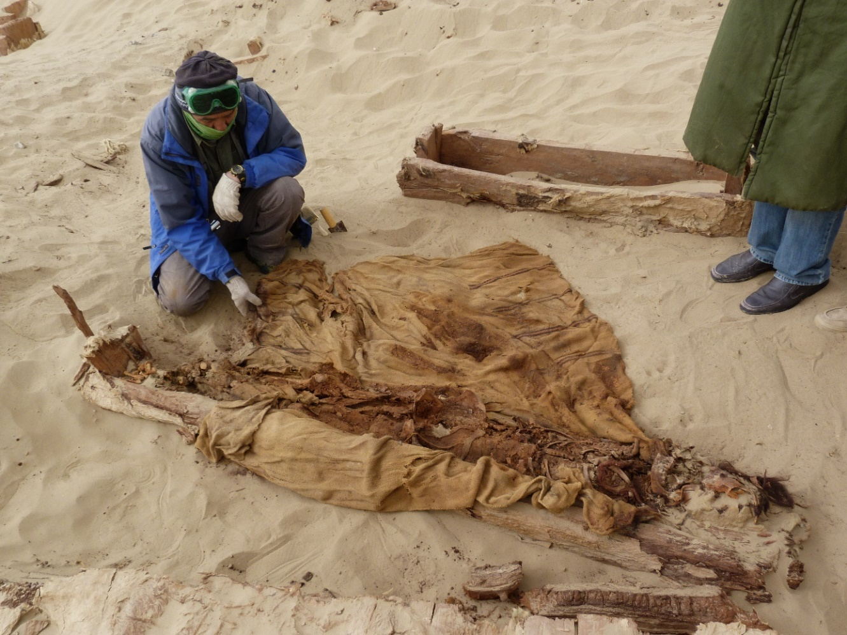

**Fig. S7 -** North Cemetery. Tomb M12. Detail of the sampled shroud. © MAFCX

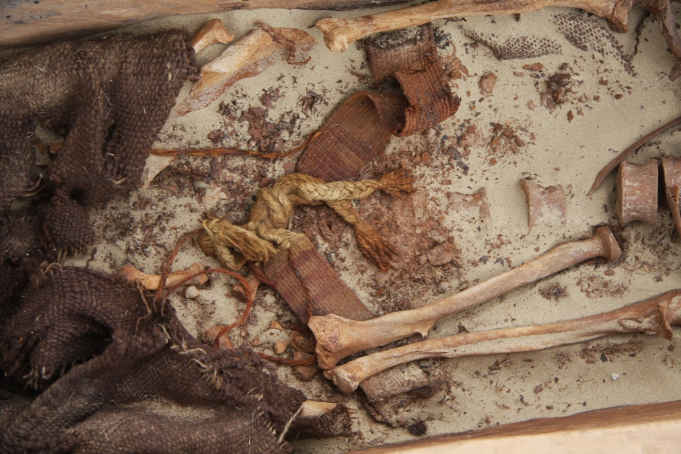

**Fig. S8 -** Djoumboulak Koum, MB Cemetery. Restitution of the sampled Tomb MB5. © MAFCX

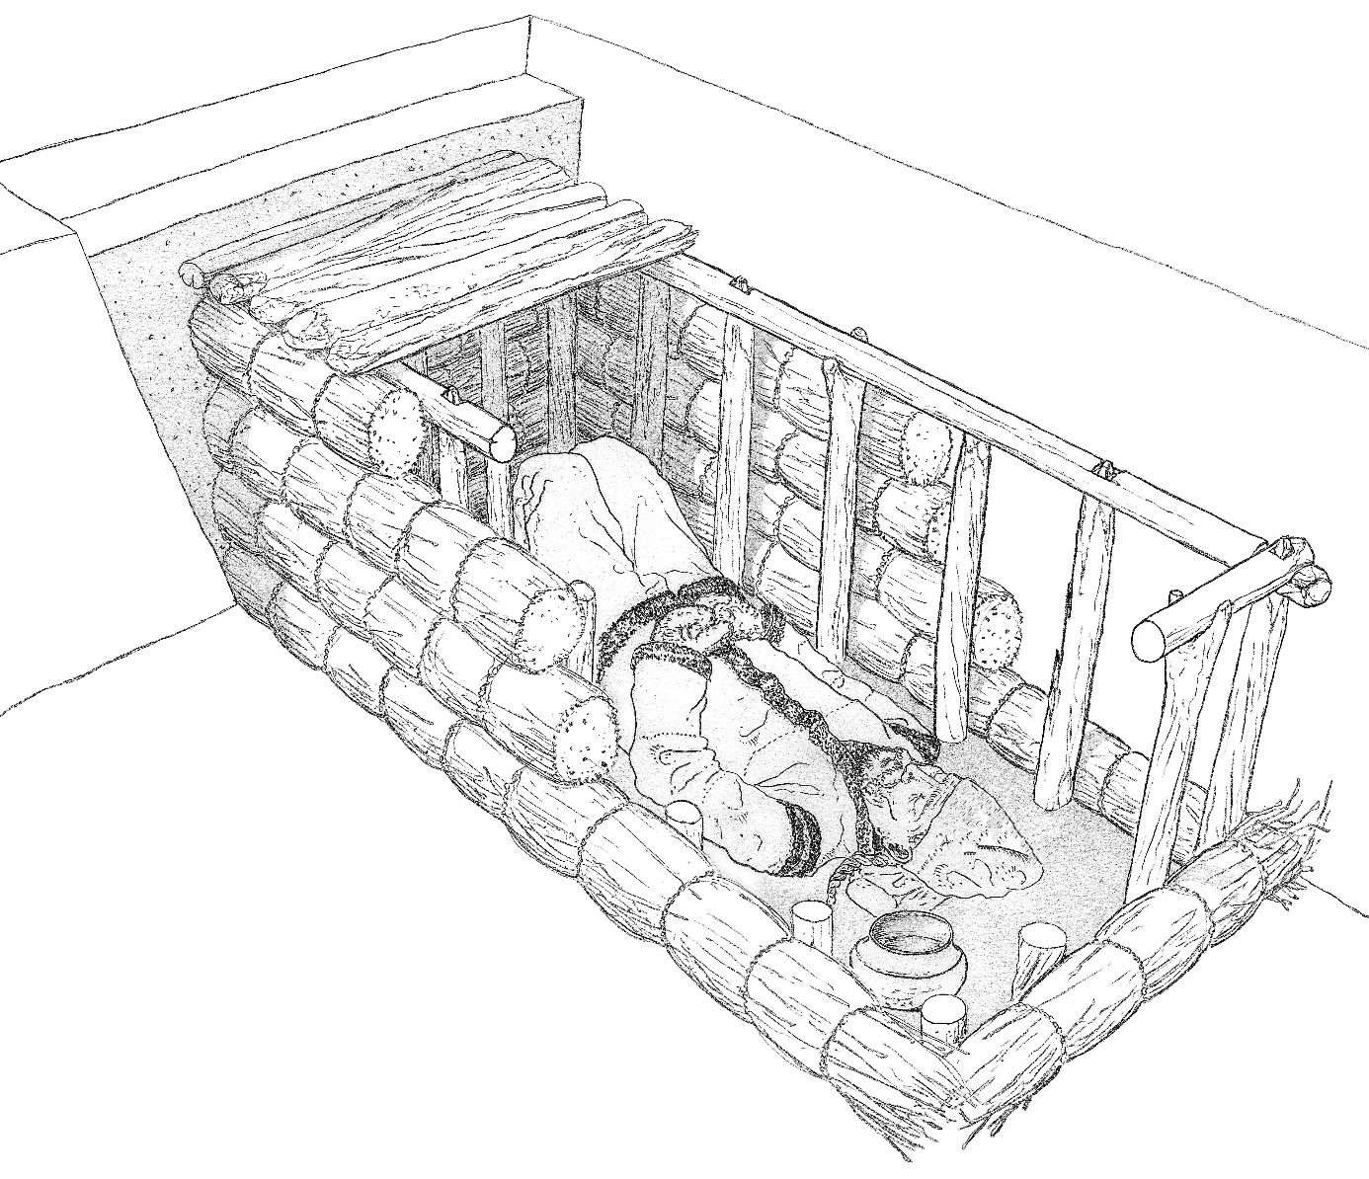

**Fig. S9 -** Djoumboulak Koum. Dwelling F4 in which textile fragments were found. © MAFCX

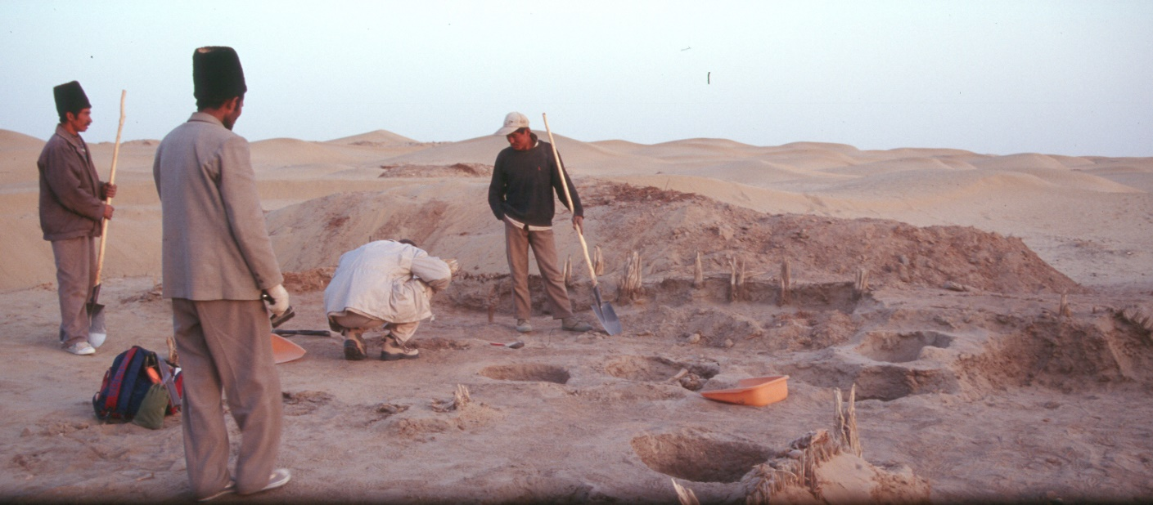

**Table S2.** Carbon and nitrogen isotopic ratios for animal samples from various archeological sites of Xinjiang dating from Bronze and Iron Age. We added 2.35**‰** to the fibre d13C values, to allow comparison between bone/enamel and fibres isotope results.

|  |  |  |  |  |  |  |  |  |  |
| --- | --- | --- | --- | --- | --- | --- | --- | --- | --- |
| Site (Xinjiang) | Date | Species | Sample | number | **13C (‰)** |  | **15N(‰)** |  | Study |
|  |  |  |  |  | MEAN | SD | MEAN | SD |  |
| Mohuchahan | Late Bronze | sheep | bone | 13 | -18,7 | 0,7 | 5,7 | 1,0 | Dong et al. 2022 |
| Liushugou | Bronze Age | caprine | bone | 37 | -17,8 | 1,2 | 8,3 | 1,7 | Dong et al. 2021 |
|  |  | cattle | bone | 11 | -19 | 0,6 | 8,9 | 1,8 |  |
| Tianshanbeilu | Bronze age | caprine | bone | 2 | -18 | 0,2 | 9,2 | 0,5 | Wang et al. 2019, 2020 |
| Goukou | Late Bronze Age | cattle tooth | enamel | 1 | -17,5 |  | 8,6 |  | Wang et al. 2018,2020 |
|  |  | caprine | bone | 5 | -18,4 | 0,7 | 5,5 | 1,4 |
|  | Early Iron Age | caprine | bone | 4 | -17,2 | 1,7 | 7,7 | 1,5 |
| Xiaohe | Bronze Age | caprine | bone | 8 | -19 | 0,3 | 8,2 | 1,2 | Qu et al. 2018 |
|  |  | bovid bone | bone | 4 | -19,1 | 0,3 | 8,6 | 0,9 |  |
| Heigouliang | Iron Age | sheep | bone | 2 | -18,7 |  | 7,7 |  | Wang et al. 2016 |
| Dongheigou/Shirenzigou | Iron Age | caprine | bone | 25 | -19,1 | 0,2 | 7,1 | 0,8 | Zhao et al. 2020 |
|  |  | cattle | bone | 3 | -19,8 | 0,2 | 7,6 | 0,8 |  |
| Wubu | Iron Age | caprine | bone | 1 | -17,9 |  | 7,1 |  | Wang et al. 2020 |
| Kalasu | Bronze Age | cattle | bone | 1 | -20,5 |  | 3,2 |  | Wang et al. 2020 |
| Xiakalangguer | Iron Age | caprine | bone | 2 | -19,4 | 0,5 | 6,1 | 0,6 | Wang et al. 2020 |
|  |  | cattle | bone | 3 | -19,5 | 0,4 | 7,4 | 0,7 |  |
| Northern Cemetery | Bronze Age | caprine | keratin | 79 | -17,4 | 1,6 | 7,9 | 1,4 | This study |
|  |  | cattle | keratin | 8 | -18,6 | 0,5 | 10,1 | 1,5 |  |
| Djoumboulak Koum | Iron Age | caprine | keratin | 12 | -17,2 | 0,9 | 9,0 | 1,04 | This study |
|  |  | cattle | keratin | 1 | -13,2 |  | 10,2 |  |  |

**Figure S10.** Distribution of the sheep 13C values in the Northern Cemetery (NC) and Djoumboulak Koum (DK)

